1.

Integer overflow attack:

An integer overflow attack occurs when an arithmetic operation on an integer variable results in a value that is too large to be stored in the variable's allocated memory space. This can cause unexpected behavior in the program, such as crashing or producing incorrect results.

Example:

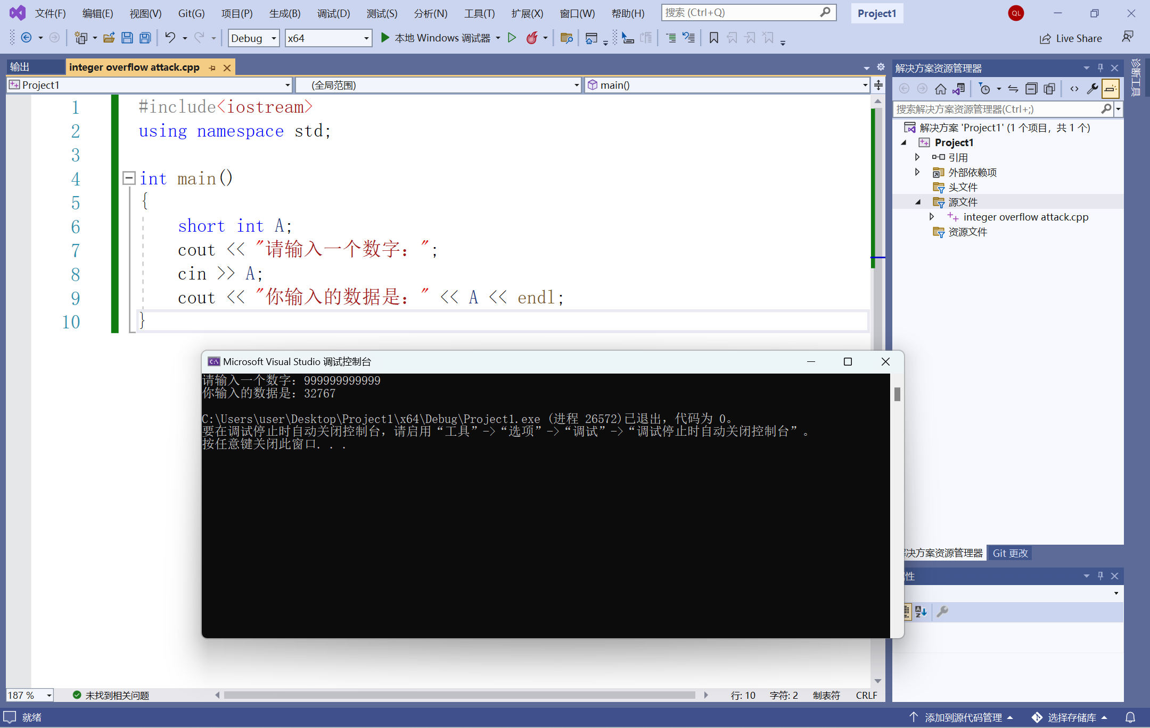

2.

Buffer overflow attack:

A buffer overflow attack is a type of security vulnerability that occurs when a program tries to store more data in a buffer than it can hold. This extra data can overflow into adjacent memory locations, potentially causing the program to behave unexpectedly or even crash.

Example:

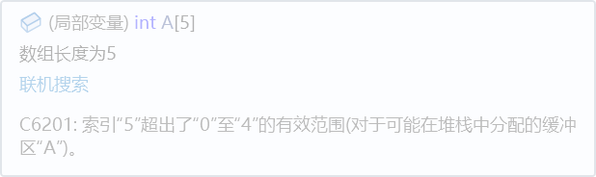

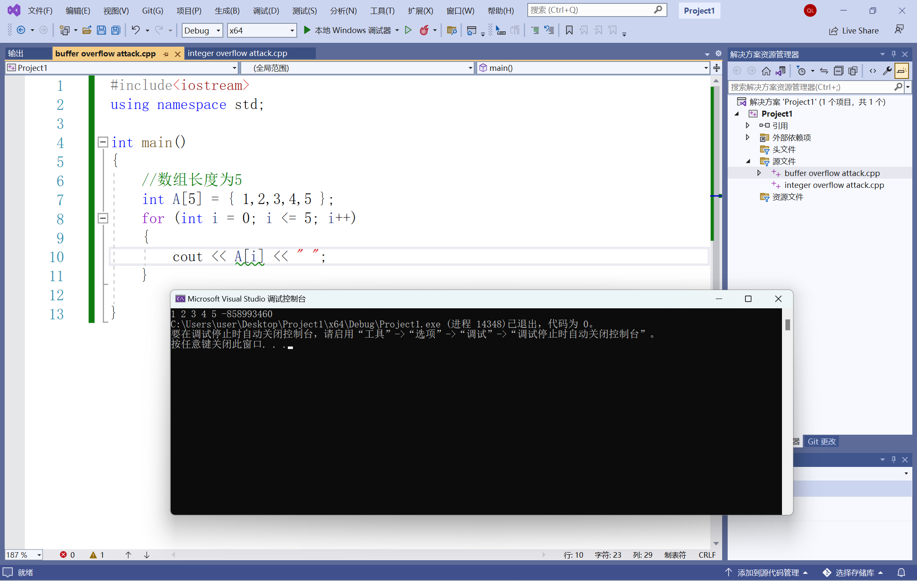

3.

Genetic diversity is a good principle for secure development because it promotes resilience and reduces the risk of catastrophic failures. Just as a diverse population is better able to withstand environmental changes, a diverse software system can better withstand attacks and adapt to new threats. A diverse software system makes it more difficult for attackers to find vulnerabilities and launch successful attacks.

Example：

Single-sign-on monoculture: Single-sign-on is a popular authentication mechanism that allows users to log in to multiple websites and services with a single set of credentials. However, many SSO systems rely on a small number of providers, such as Google, Facebook, and Microsoft. This creates a monoculture in which an attack on one of these providers could have widespread consequences for the entire ecosystem.

4.

Incomplete mediation is a type of security vulnerability that occurs when an application fails to properly validate and sanitize user input. This can allow an attacker to bypass security controls and perform unauthorized actions or access sensitive information. Incomplete mediation occurs when an application performs some, but not all, necessary security checks on user input.

* The potential problems with incomplete mediation include:

Authorization bypass: Incomplete mediation can allow an attacker to bypass authorization checks and perform actions that they are not authorized to perform. For example, an attacker might be able to access sensitive information or modify settings that should only be accessible to an authorized user.

Injection attacks: Incomplete mediation can also lead to injection attacks, such as SQL injection or command injection, where an attacker can inject malicious code into an application's input fields.

Data tampering: Incomplete mediation can allow an attacker to modify data that is stored in an application's database, leading to data tampering or data loss.

* To better check user input and prevent incomplete mediation vulnerabilities, developers can take the following steps:

Input validation: Validate all user input and sanitize it to ensure that it is in the correct format and does not contain any malicious content. This includes validating input type, length, format, and range.

Output encoding: Encode all output to prevent injection attacks. This involves encoding special characters and HTML tags to prevent them from being interpreted as code.

Access control: Implement access control checks to ensure that users are only able to perform actions that they are authorized to perform. This includes checking user roles and permissions, as well as enforcing least privilege principles.

Security testing: Perform regular security testing, including penetration testing and vulnerability scanning, to identify potential vulnerabilities in an application's input validation and access control mechanisms.

5.

Code review: One effective control for detecting off-by-one errors is to perform code reviews. During a code review, another developer can carefully examine the code to ensure that index values are being used correctly and that no off-by-one errors are present.

Automated testing: Another control that can be used to detect off-by-one errors is automated testing. This can include unit tests, integration tests, and other types of testing that can check for boundary conditions and other scenarios that might trigger off-by-one errors.

Input validation: Finally, input validation can be used to prevent off-by-one errors from occurring in the first place. This involves carefully validating all input that is being used to index arrays or loops to ensure that it is within the expected range and that it is not one too high or one too low.

6.

* Threat:

Malware: The memory stick could be infected with malware, such as a virus or Trojan, which could infect your work computer and compromise its security.

Data theft: The memory stick could contain malware or other tools that are designed to steal data from your work computer, such as login credentials or sensitive documents.

Unauthorized access: The memory stick could contain tools or software that enable an attacker to gain unauthorized access to your work computer, such as remote access software or password cracking tools.

* Steps:

Do not plug in the memory stick.

Use antivirus software.

Use a limited-access user account with restricted privileges when examining the contents of the memory stick.

7.

Malware: The custom code that you are asked to install could be infected with malware, such as a virus, Trojan, or spyware. This malware could compromise the security of your computer system and steal sensitive information or damage your files

Unauthorized access: The custom code could be designed to give an attacker unauthorized access to your computer system, either directly or through a backdoor or remote access tool.

Data theft: The custom code could be designed to steal data from your computer system, such as login credentials, financial information, or other sensitive data.

8.

* Here are some types of malware that could cause these symptoms:

Botnet: A botnet is a network of infected computers that are controlled remotely by an attacker. If your computer is part of a botnet, it could be generating a large amount of network traffic as it receives commands from the attacker.

Trojan: A Trojan is a type of malware that appears to be legitimate software, but in fact contains malicious code that can perform a variety of harmful actions on your computer, including generating network traffic and slowing down system performance.

* The malware may have gained access to your system through a variety of means, such as downloading a malicious email attachment, visiting a compromised website, or downloading a software update from an insecure source.
* To check whether your computer has been infected with malware, you can use antivirus or anti-malware software to perform a scan of your system. This software can detect and remove most types of malware infections.
* Solutions:

Run a malware scan: Use antivirus or anti-malware software to scan your computer and detect and remove the malware.

Update your software: Make sure that all of your software, including your operating system, web browser, and other applications, are up-to-date with the latest security patches and updates.

Change your passwords: Change your passwords for all of your online accounts to prevent the attacker from accessing your personal information.

9.

* Clickjacking is a type of attack in which an attacker tricks a user into clicking on a hidden or invisible element on a web page by overlaying it with a legitimate-looking element. This can result in the user unwittingly performing actions that they did not intend, such as clicking on a link or button that initiates a malicious download or executes a fraudulent transaction.
* implementing frame-busting code and using headers such as X-Frame-Options and CSP can help browsers detect and prevent clickjacking attacks.

10.

* Spam senders frequently change their email addresses and domains in an attempt to avoid being blocked or marked as spam by email filters and blacklists. When an email address or domain becomes associated with spam, it can quickly become ineffective for the spammer, as many email providers and spam filters will automatically block or flag messages coming from that source.
* Because the messages themselves often contain identifying information, such as the content of the message, the sender's name, or the sender's IP address. Additionally, many spam messages contain links to websites or contact information that can be used to track the sender or respond to their message.

11.

A web server needs to know the address, browser type, and cookies for a requesting client in order to provide an optimal user experience and to maintain security.

The address of the requesting client, also known as the IP address, is used by the web server to identify the location of the client and to route the response back to the correct destination. This information can also be used for security purposes, such as identifying and blocking malicious IP addresses or monitoring for unusual activity.

The browser type of the requesting client is used by the web server to optimize the content it serves to the client. Different browsers have different capabilities and limitations, and the web server can use this information to provide content that is compatible with the client's browser. For example, the server can deliver a mobile-friendly version of a website to a client using a mobile browser.

Cookies are small text files that are stored on the client's device by the web server. They are used to store information about the client's preferences, login credentials, and other data that can be used to personalize the user experience. For example, a web server can use cookies to remember a user's login information or to store items in a shopping cart.